William S. Hart on DVD: The Silent Man
Bill West
Howdy Pard’s. Time again to look at another fine film of our friend William S. Hart. This time it’s the aptly titled “The Silent Man” which was made in 1917, and was the first film Bill released under Adolph Zukor’s “Artcraft” production company. Bill had left the Triangle Film Corporation for Artcraft where he received his own office, staff and more money! There was a downside to this arrangement though, as Bill had less control, and the pace of the filmmaking was more hurried.
This film, for example, was listed as being directed by Bill, but in reality was probably directed by Lambert Hillyer who was the staff director for all of the Artcraft pictures. This new arrangement also forced out Thomas Ince as the producer, and relegated him to “Production Supervisor.”
Worst of all, for us Hart Flicker Fans, the newer faster pace gave Ince the ammunition he needed to do the thing he always wanted to do: force Fritz out of Bill’s pictures. Perhaps it was Fritz’s small stature, being a pony, next to the 6’3” Hart, or it was Hart’s doting on Fritz, but whatever the reason, Ince never did care for Fritz in the pictures. Under Artcraft, he could apply the pressure needed to force poor Fritz into an indoor stall near Ince’s studio for the next two years. (Hart did manage to insist on using Fritz on only one Artcraft picture, The Narrow Trail, which was actually filmed before The Silent Man, but released later.)
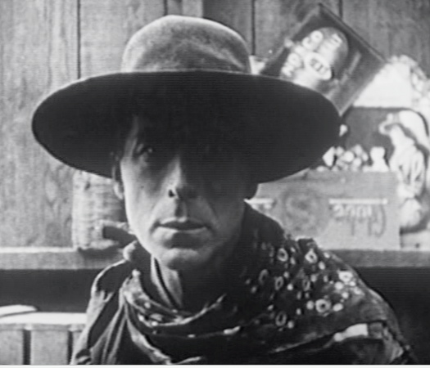
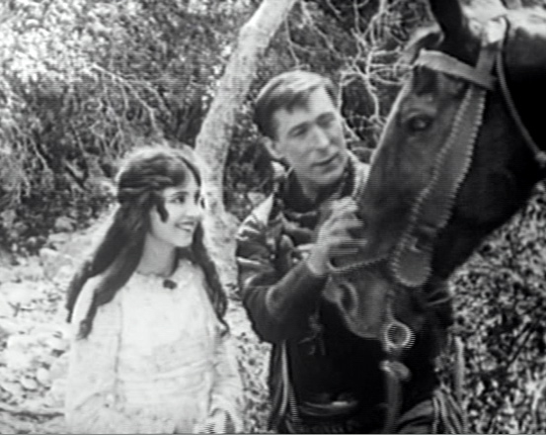
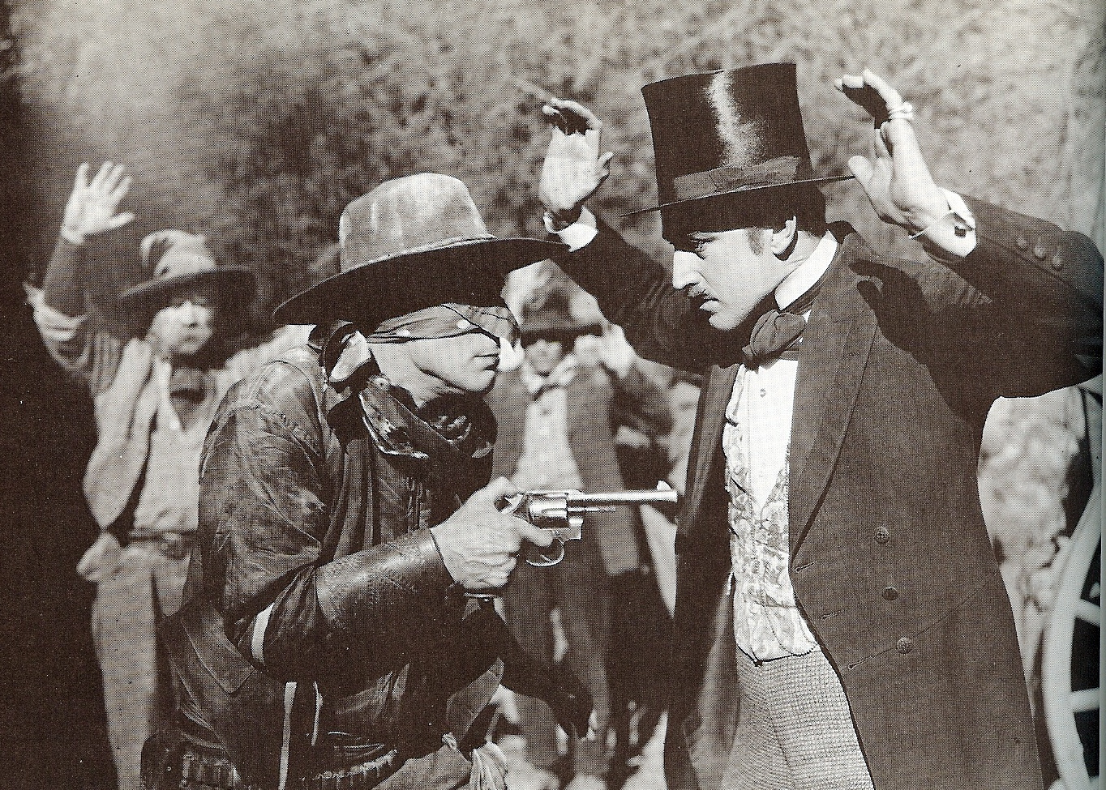
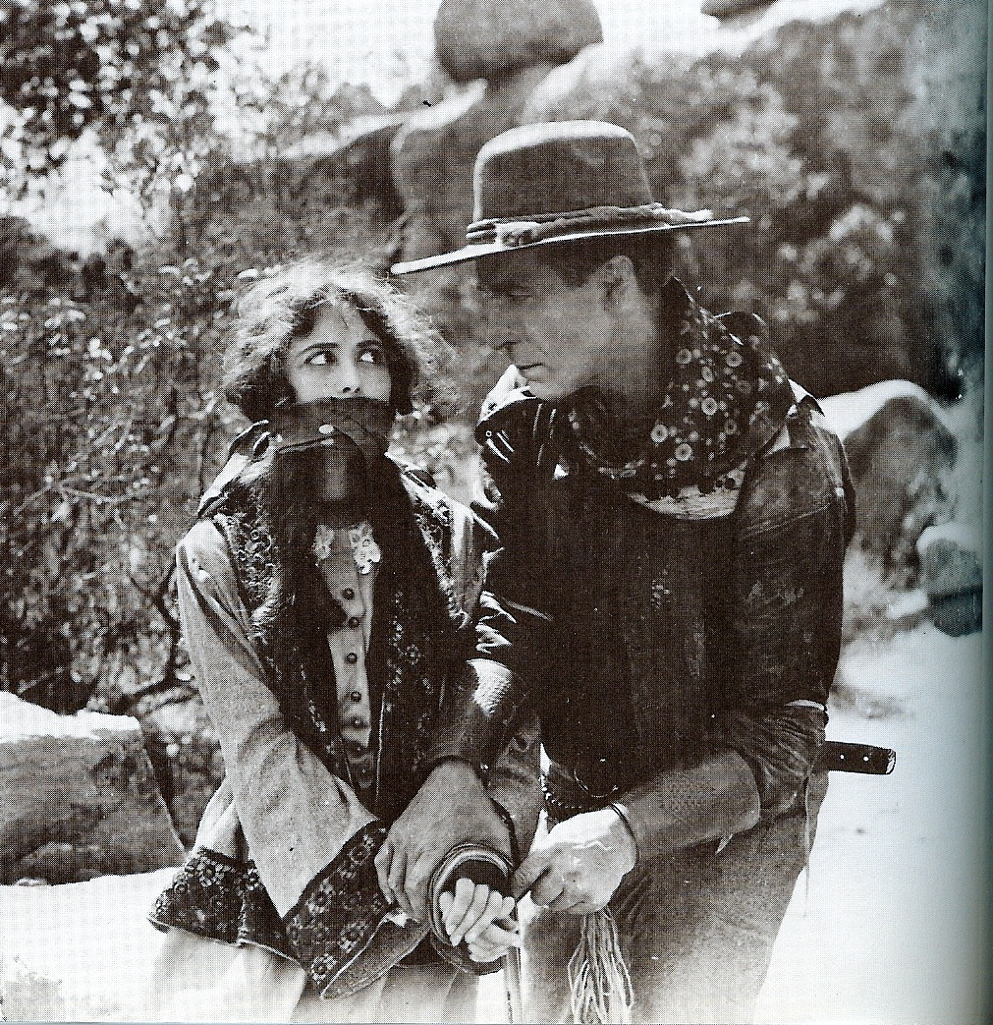
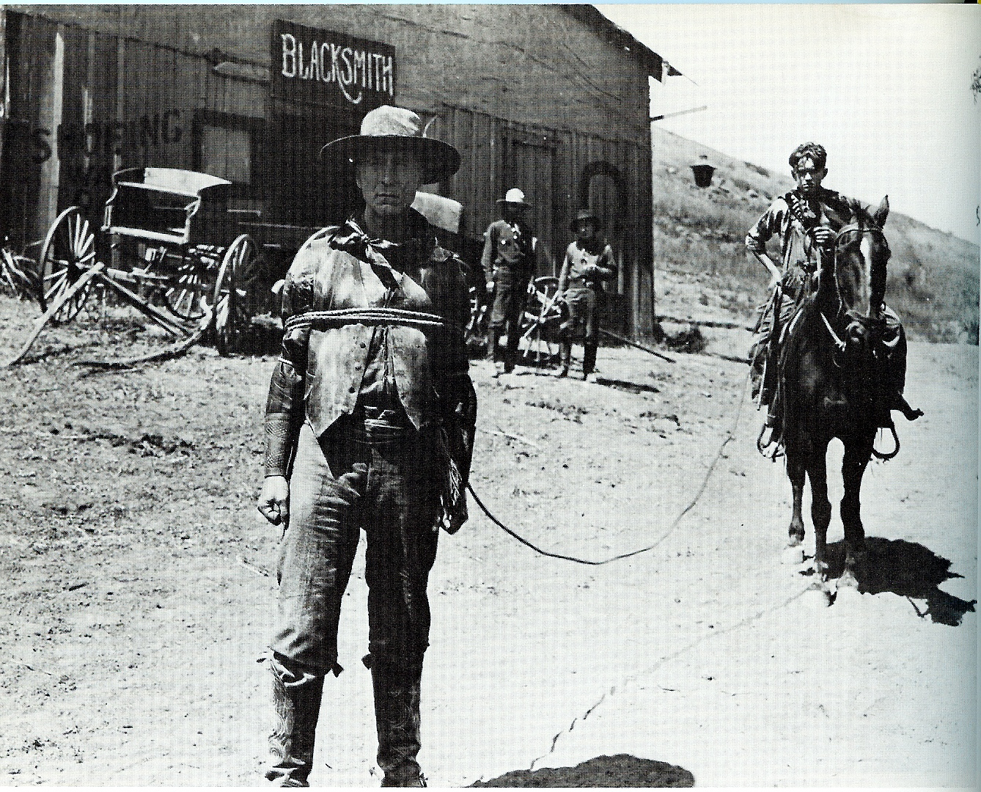
This poor treatment of Fritz, plus several other factors eventually lead to the split between Hart and Ince, the man that had brought Hart to Hollywood.
Having said all that, despite the pressure Hart was put under at Artcraft and the lack of Fritz, The Silent Man is actually a very fine film. In this one, Hart is a desert prospector who gets cheated out of his stake. The action takes place in two of those wonderfully named towns that Hart films often have: in this case the desert towns of “Bakeoven” and “Chloride.” And, despite the title of the film, there’s plenty of “dialog” in the form of title cards with wonderful writing and humor. One of them even uses some special effects to great effect: the card refers to the bad guy as “a dad-blasted ornery ...” followed by a scenes of fireworks to substitute for the impending cussing!
The plot is a strange tale of cheating, kidnapping and polygamy! Our hero is a good guy in this one, and yet due to the intricacies of the clever plot, we find Hart the perpetrator of one of kidnappings and of a robbery. He even professes to be guilty, gives himself up (allowing a small boy to pose as his capturer) so a family in need can have the reward! The picture ends with a courtroom scene which is followed by a surprise twist ending that I won’t give away. All in all, great fun!
The bad guy in this picture is played finely by Robert McKim, the same fellow who played in several Hart films, including as the slimy bad guy Arizona Joe in “The Return of Draw Egan,” which you may have seen at this year’s Silents Under the Stars at Hart’s Mansion. The love interest in this picture was played by the beautiful and popular Vola Vale, who also appeared in several of Hart’s films.
DVDs of this film (in the DVD-R format which plays fine on all but the oldest players) are available from two sources, and each one has its own advantages, outlined below:
SinisterCinema.com (541) 773-6860: has a better quality print, with a rousing orchestral accompaniment that doesn’t always match the action. It includes a Kermit Maynard movie trailer for his film “Code of the Mounted” for $11.95 plus $2.55 for shipping. There are discounts for buying more titles, and Sinister has quite a few Hart DVD and VHS offerings.
ReelClassicDVD.com (201) 463-6118: is 12 minutes longer (totaling 59 minutes) than the Sinister Cinema version, but the quality is not quite as good. It has a nice accompaniment composed for the movie that does generally match the action, but isn’t as lively and is performed entirely on a synthesizer keyboard. Their DVD includes a 15 minute, silent 1925 documentary on “Making a Stetson” that’s quite fun. They charge $20 plus $3.50 shipping, and also have some other Hart titles.

